Attachment B – Site and Location Maps
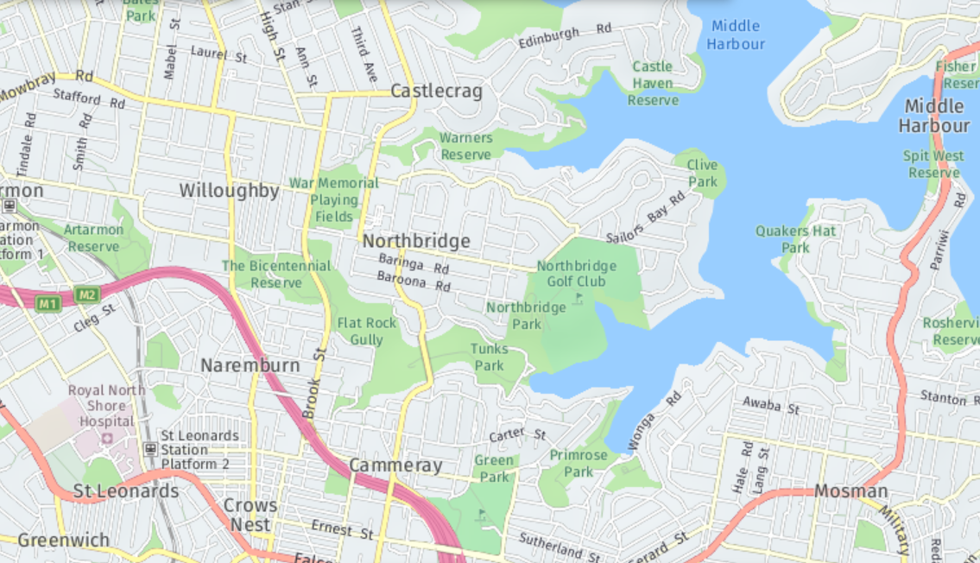
Subject site
Figure 1: Site Location (Source: Nearmaps)
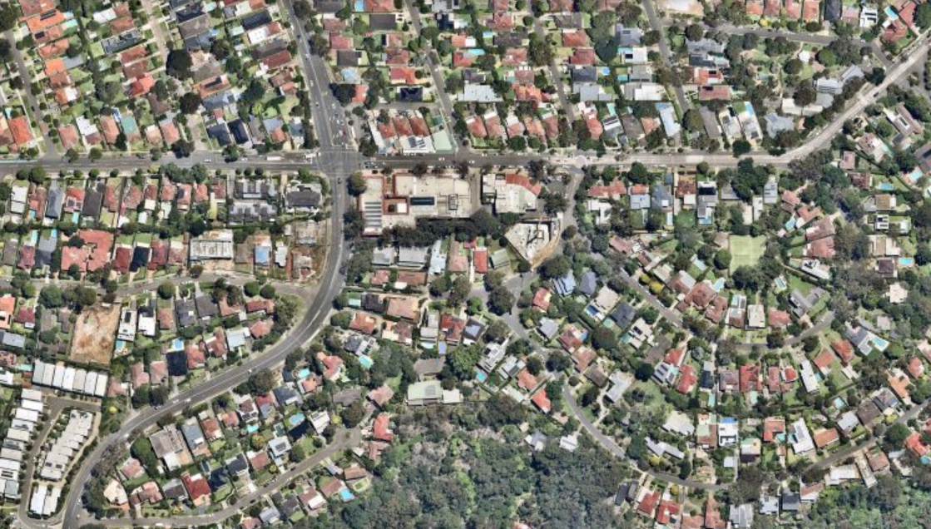
The Postern
Eastern Valley Way
Edinburgh Road
N
Subject site
Figure 2: Subject site (Source: Nearmaps)
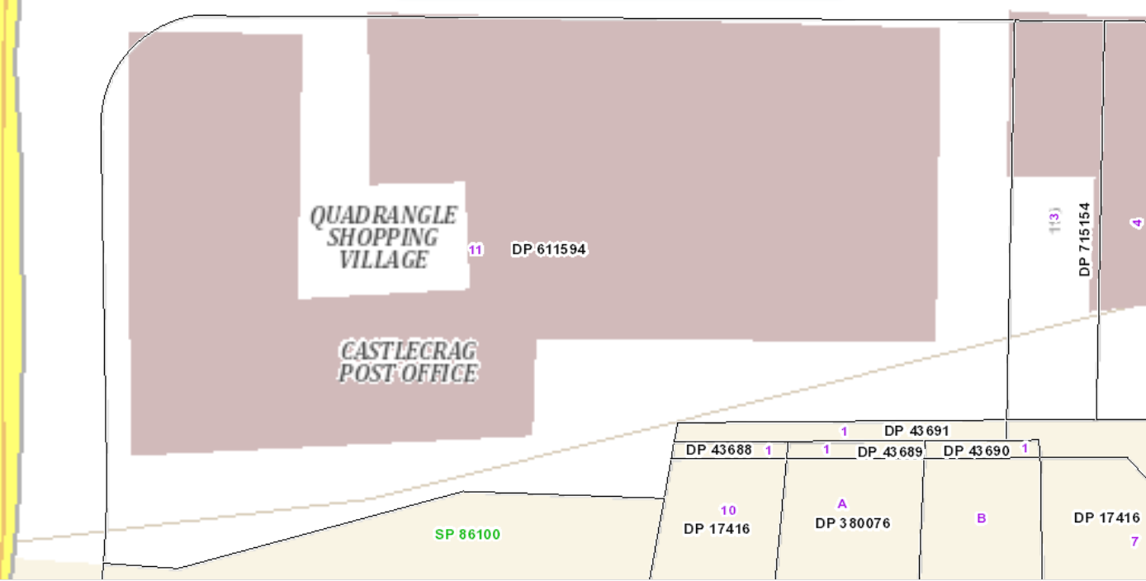
Figure 3: Subject site lots (Source: Sixmaps)

